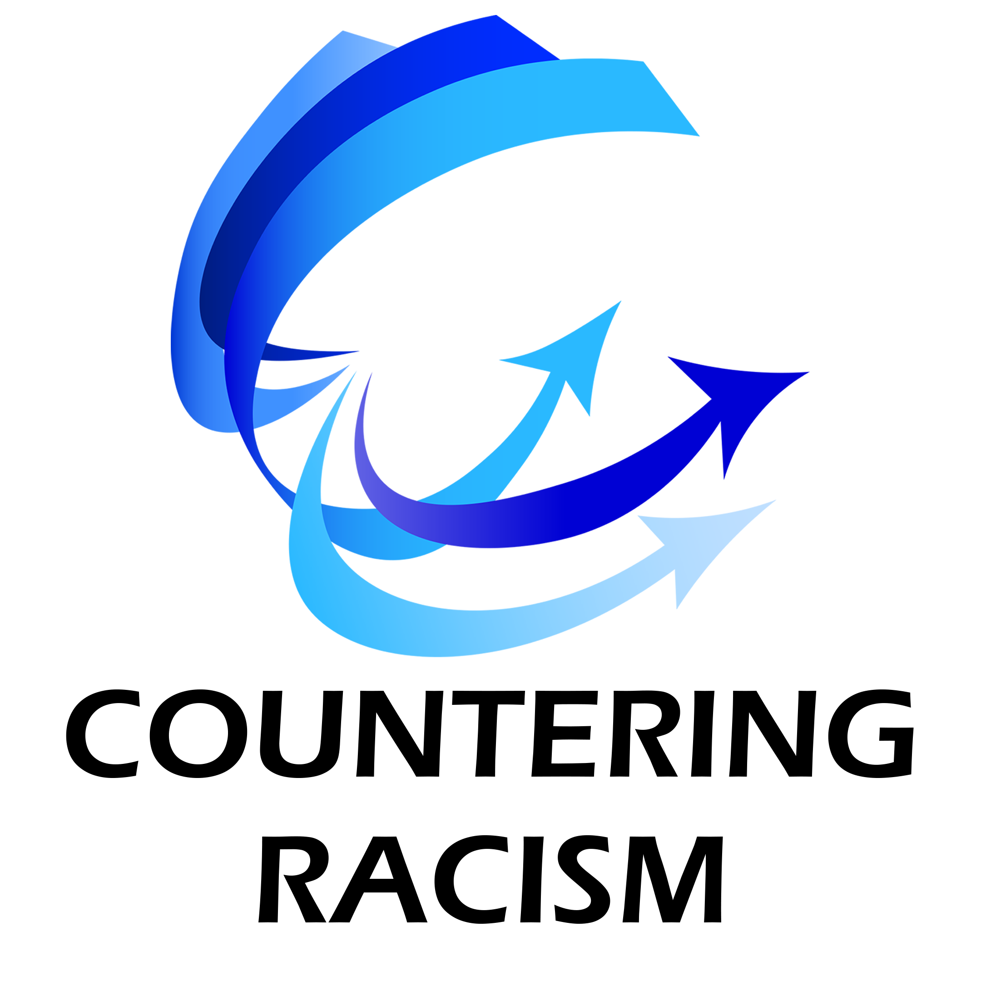

Successfully Leading Journeys of Change
“Being Worthy of Followers”

- There are 3 phases in leading journeys of change.
- There are 6 leadership roles, each with 3 core strategies.
- Disciplined adaptation of the roles and strategies is always the key.

Phase One – “In the Beginning”

Leadership Roles | Core Change Strategies (& natural questions) | Adaptation for Countering Racism | Actions to Take
The
Visionary

 | Build the Business Case for the Change  (Why are we going forth on this journey?) | Why are we embarking on this journey of change?  Why leave our comfort zone? What’s driving this change? What are the consequences if we don’t change? (Threat driven energy)  - Moral factors  - Social factors?  - Financial factors?  - US position in the world?  - Individual self-image/integrity?  Why confront racism? Why make the effort/investment? Why face the unknown and potential losses? What are the opportunities if we do change successfully? | ♦  ♦  ♦
 | Create the Vision of the “Desired State”  (Where are we going?) | Where are we going?  What’s the “big picture” look like? What might we achieve/create? What might we look like as a country? As a local community? As an organization? As an individual?  What might that feel like (integrity, power, connection, opportunity, confidence, pride, etc.)? As a White person? A Black person? As an American? As a community?  What might the impact (ripple effect) be on Whites, Blacks, our communities? Our organizations? The country as a whole?  What might interim visions look like – desired states to achieve along the path to the ultimate desired state? | ♦  ♦  ♦
 | Establish the Leadership Commitment  (Is leadership worth following?) | How will this initiative be led?  People will have natural questions about leadership and the answers will determine how much they commit and are willing to invest or sacrifice.  What kind of leadership structure will there be? Who is leading this initiative? What is the racial balance? How competent are the leaders in this structure? Are there enough leaders?  Are they aligned or competing? How committed are they really? Will they persevere and “hold the course?”  What behaviors can you expect to see from us? What behaviors will you not see? How will leadership hold itself accountable? How transparent will leadership be? | ♦  ♦  ♦
The
Architect

 | Create the Organization or Community Design  (What will the required organization or community look like?) | What organization or community will we need to build?  What do we need to put in place to achieve the vision?  “Things” - Structure, processes, systems, policies and laws, IT, facilities, etc.?  “People” – qualities, roles, relationships, behavioral norms, values, capabilities, the culture?  What are the most critical elements for our envisioned change? What will be changing significantly and what will not?  How will this organization or community design address the individual, group and systemic aspects of racism in our organization or community? | ♦  ♦  ♦
 | Build the Plan(s) for the Journey  (What does the roadmap look like?) | What do we need to do to achieve the vision?  Who is going to do what (goals), by when and how? How much authority and responsibility do people have? Where are the check-points for review and approval? What resources are going to be committed? What quick wins are possible? | ♦  ♦  ♦
 | Create the Core of the Leadership Web  (Who is at the center of the leadership?) | Who is at the center of the web of leaders?  Who are the senior leaders? Who is on the core leadership team? How were they selected? How strong are they? Did they get there based on capability or are they “representative?” What is the racial balance?  How aligned are they? Are they up to the challenge? Can we trust them to keep us safe on this journey and reach the desired state? | ♦  ♦  ♦
Phase Two – “On the Path”

Leadership Roles | Core Change Strategies (& natural questions) | Adaptation for Countering Racism | Actions to Take
The
Catalyst

 | Extend the Leadership Web  (Who is going to be brought into leadership and how much leadership will we have?) | How far can we extend the leadership web?  Who can we add? How do we recruit and integrate them into the change process? Is the process the same for White and Black leaders?  What roles can they play and how can they play them? How do we prepare them for success – capabilities, connections, support?  Does the envisioned leadership web have the reach and capabilities to match the challenges? | ♦  ♦  ♦
 | “Operationalize” the Vision  (What will day-to-day reality look like in the envisioned desired state?) | What would the vision and organization or community design look like in real-time operation?  What would it look like “on the ground” or “day-to-day?” Overall? What is required to really make the vision and design work in reality?  What would be required and what would it be like for different units? What would it be like for people to be a part of the operations?  Who do we bring into the process to add the right details? How do we orient them and support them in completing the picture? | ♦  ♦  ♦
 | Prepare the People & Organization or Community  (Will we be prepared for success on the journey – or just thrown in?) | Are people ready and are they prepared to be successful?  How ready are White people for the envisioned change and what will be required of them to get to the desired state? How ready are Black people?  What preparation is required for the organization or community as a whole? For Black people? For white people? For specific parts of the organization or community? | ♦  ♦  ♦
The
Guide

 | Create a System for Communication  (What will we hear? How will we be heard? How will we engage each other?) | How do we communicate “out”, “in” (feedback), and “among” ourselves?  How do we get information out to people? Methods, channels, style, timeliness, transparency, accuracy?  How do we communicate the current reality of racism, our vision of how it could be, how we will lead the journey to achieve that vision, etc.?  How do we get feedback, so that we know what’s going on, how people are experiencing the change and where the threats and opportunities are? How are Black people experiencing the journey? How are White people experiencing it?  How do we stay connected and communicate among ourselves to problem solve, align and support each other? How do we connect people? White to White? Black to Black? White to Black? Rich to poor? Young to old?  How do we change the system as the change progresses from an “out” focus to an “in” focus” (and an “among” focus) | ♦  ♦  ♦
 | Support People in Letting Go & Dealing with “Inbetweenity”  (What kind of support will we get – or are we just on our own?) | How do we help people let go of old ways and deal with all the “dynamic tensions” of being in-between letting go and mastering the new?  Letting go of beliefs, perspectives, biases, self-images, behaviors, norms and patterns, knowledge of racial issues?  How do we help people deal with the endings and losses? Psychologically? Socially? Materially? Spiritually?  How do we help people manage the inevitable tensions and anxieties of changing in regard to race: of knowing vs. not knowing, confidence vs uncertainty, excitement vs. fears, hopes vs. doubts, etc.? | ♦  ♦  ♦
 | Establish a System of Healthy Accountability to Stay on the Path  (How will we know how we are doing, learn from the experience and figure out what to do next?) | How do we “stay on the path and stay healthy and energized?”  How are we doing in moving toward the vision of the desired state? What are we measuring? How are we doing as leaders?  Have we doing in building the organization or community required for success on this racial journey? Have we connected people and are we building the required capabilities?  Are we asking ourselves the right questions and acting on our discoveries?  What do we have to celebrate? What have we learned? What do we need to keep doing? Stop doing? Start doing?  How do we renew energy and commitment and hope over the long period of the journey?  How do we attend to those suffering on the journey? | ♦  ♦  ♦
The
Builder

 | Maintain & Develop the Leadership Web  (How will leaders – and followers – keep from wearing down? Re-energize? Keep relationships healthy?) | How do we continue to extend the web of aligned leaders and followers and how do we develop its capabilities and maintain its health.  Where are the new leaders and followers and how are we engaging and preparing them? How are we supporting and honoring followers for what they do (the overlooked factor in leadership)?  What kind of leadership works in different settings? How is Black and White leadership playing out in similar ways? How does it differ?  Who is getting worn out and how do we renew them? What relationships are fraying and how do repair them? Where are the gaps and how do we fill them? Is the core leadership team performing as – and perceived to be – a high performance team?  How do we spread what works and recover from what isn’t working? | ♦  ♦  ♦
 | Build the Required Competencies  (How do we build the capabilities required on the journey and in the desired state? Individual? Group? Organizational? Community?) | How do we build the individual, group, and systemic capabilities required for success on the journey and in the desired state?  To successfully counter racism what individual knowledge and capabilities must we build and how will we build them? What group and inter-group capabilities are required? What systemic (organizational and community) capabilities must we build?  Required capabilities will be in race related areas and areas not related to race. There are a lot of capabilities that will need to be developed to close the racial gaps and counter systemic racism and overcome internalized racism or internalized oppression. How focused are we?  There are also capabilities required for performance related to the health of organizations and communities that are tangential to, but also key to closing racial gaps. Are we focused on those? | ♦  ♦  ♦
 | Support People in the Mastery Process  (Mastering new competencies is tough - what kind of support will we get?) | How are we supporting people in the long and challenging process of mastering the required capabilities?  Individuals? Groups and teams? Organizations and communities?  How are people doing in “learning to love the plateaus” – the often-long periods of effort without a lot of progress - with setbacks and disappointments and sometimes failures?  What are we modelling as leaders? Have we prepared people for the mastery process?  How many people are pulling back or dropping out and how do we prevent or respond to that? | ♦  ♦  ♦
Phase Three – “In Completion”

Leadership Role | Core Change Strategies (& natural questions) | Adaptation for Countering Racism | Actions to Take
The
Integrator

 | Manage the Ripple Effect  (What happens to others when we change and what will we do about managing that impact?) | How is our change affecting others and how can we manage that impact?  Countering racism will have a major ripple effect in a large number of scenarios and will affect most people and communities in the country.  What stakeholders are being impacted and how much? Positively? Negatively? What negative impacts can we avoid? Minimize or compensate for? What positive impacts can we enhance?  What is the impact in White communities? Black communities? Similar impact? Different?  If finances change, what is the impact on different stakeholders?  What can we prepare for? What will we have to watch and be ready to act on? | ♦  ♦  ♦
 | Align the “Things” of the Organization or Community  (We are going to naturally throw things out of alignment – how do we get things re-aligned?) | How do we align the “things” to achieve synergy?  Do our new systems, policies or laws and procedures all work smoothly together? Does our structure and role definition fit? What “things” have changed and what do we need to do to ensure that the natural misalignment that causes is dealt with as early as possible? | ♦  ♦  ♦
 | Attune the People of the Organization or Community  (How will people come together around the new perceptions, beliefs, values, norms, etc.?) | How do we attune the people of the organization or community so that there is “fit” with the emerging reality?  How do we develop common ground, values, behaviors, leadership and management styles, relationship norms, perceptions and beliefs, etc.?  How do we track where there is a lack of attunement and respond? How do we “hold the course” over the long period of time required for attunement? | ♦  ♦  ♦

Remember

- The model is solid, but the magic is in the adaptation and execution.
- Successful adaptation and execution will require three forms of courage:
- The courage to see the truth
- The courage to put forth a clear and specific vision of the desired state
- The courage to work with and rely on others
- Successful execution will also require extraordinary discipline, perseverance, and resilience.

Note. This is a Word document, so it will expand to accommodate your thoughts and it can be revised to best match your style/needs.

www.counteringracism.org

