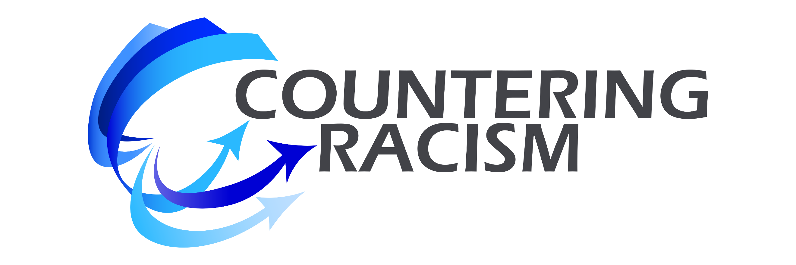 | MY VISION – THE POSSIBLE BENEFITS  What can be created – why go forth –  what’s worth the commitment & journey?
DOMAIN | POSSIBLE BENEFITS | MY ACTIONS
INDIVIDUAL
Fast track to personal growth.
INTERPERSONAL
Enhanced interpersonal competence, richness, and enjoyment.
MY ORGANIZATIONS
Moral case and business case.
MY COMMUNITIES
Specific outcomes & community development.

